SpringBoot Application-Pipeline Project

As pipeline project with Groovy script

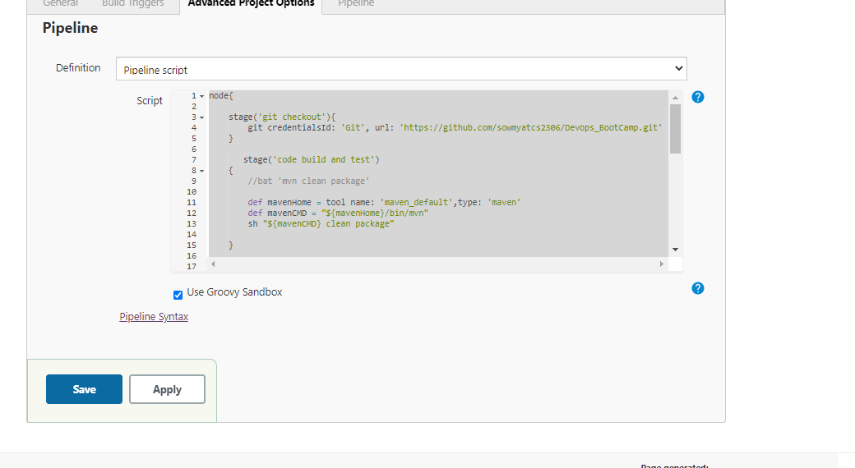

node{

stage('git checkout'){

git credentialsId: 'Git', url: '<https://github.com/sowmyatcs2306/Devops_BootCamp.git>'

}

stage('code build and test')

{

def mavenHome = tool name: 'maven_default',type: 'maven'

def mavenCMD = "${mavenHome}/bin/mvn"

sh "${mavenCMD} clean package"

}

stage('docker build')

{

sh "sudo docker build -t sowmyatcs2306/springboot:4.0 ."

}

stage('docker push')

{

withCredentials([usernamePassword(credentialsId: 'docker', passwordVariable: 'docker_pass', usernameVariable: 'docker_user')]) {

sh "sudo docker login -u sowmyatcs2306 -p ${docker_pass}"

sh "sudo docker push sowmyatcs2306/springboot:4.0"

}}

stage('docker run')

{

sh "sudo docker run -p 9090:9090 -d sowmyatcs2306/springboot:4.0" }

}

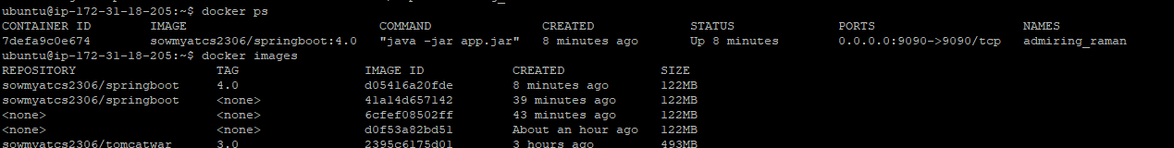

ubuntu@ip-172-31-18-205:~$ docker ps

CONTAINER ID IMAGE COMMAND CREATED STATUS PORTS NAMES

7defa9c0e674 sowmyatcs2306/springboot:4.0 "java -jar app.jar" 8 minutes ago Up 8 minutes 0.0.0.0:9090->9090/tcp admiring_raman

ubuntu@ip-172-31-18-205:~$ docker images

REPOSITORY TAG IMAGE ID CREATED SIZE

sowmyatcs2306/springboot 4.0 d05416a20fde 8 minutes ago 122MB

**Output**

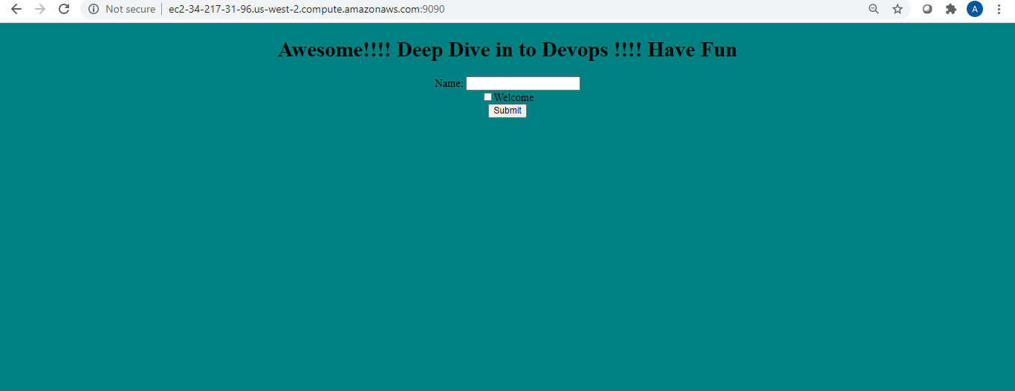

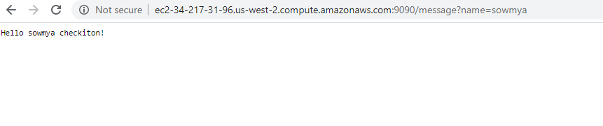

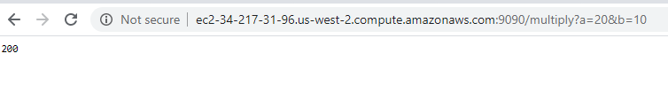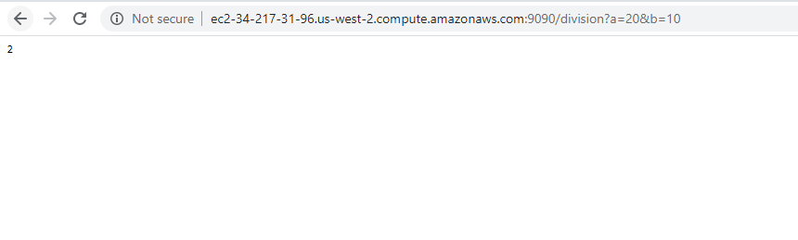

**DockerHub**

